**DESIGN AND FABRICATION OF LOW COST SMART OPEN DRAINAGE CLEANING SYSTEM FOR MUNICIPOLITY**

**STUDENT PROJECT PROPOSAL**

*Submitted to*

**TAMILNADU STATE COUNCIL FOR SCIENCE AND TECHNOLOGY**



**DEPARTMENT OF MECHANICAL ENGINEERING**

**K.S.RANGASAMY COLLEGE OF TECHNOLOGY**

*(Autonomous)*

**K.S.R. KALVI NAGAR, TIRUCHENGODE-637215.**

**NAMAKKAL (DT), TAMILNADU**

**AUGUST-2019**

**TAMILNADU STATE COUNCIL FOR SCIENCE AND TECHNOLOGY**

**STUDENT PROJECT PROPOSAL – 2019 – 2020**

**1.Name of the Students** : G.Sathiyamoorthy,G.Vinoth,P.Chandru,J.Vivekanandhan.

**E-mail id** :vivekmech249@gmail.com

**Name of the Guide** : Mr.K.Raja M.E.,

**Designation**  : Assistant Professor

**Institutional Address** : K.S.Rangasamy College of Technology, Tiruchengode-637215.

**Phone No.& Mobile No.** : 04288 274741 & +91 9842314481

**5.Project Title** : Design and Fabrication of low cost smart open drainage

Cleaning system for municipolity

**6.Sector in which your Project** :Engineering & Technology

**Proposal is to be considered**

**7.Project Details** :Enclosed in Annexure –I

**Has a similar project been**

**Carried out in your college/**

**Elsewhere?if so furnish details of :**NIL

**the improvements suggested in the**

**present one.**

**CERTIFICATE**

This is to certify that **G.Sathiyamoorthy, G.Vinoth, P.Chandru, J.Vivekanandhan**are a bonafide final year student of U.G. Engineering course of our college and it is also certified that two copies of utilization certificate and final report along with seminar paper will be sent to the Council after completion of the project by the end of April 2016.

Signature of the Guide Signature of the HOD Signature of the Principal/

Head of the Institution

**1. INTRODUCTION**

Water is a basic necessity of humans and all living beings.The most striking feature of Harappa civilization (Indus Valley Civilization) is that the Indus Valley people had constructed their drainage system on very scientific lines . Open drainage system and closed drainage system are the two types of drainage system.

As long as the drainage system is considered the function of the main drainage system is to collect, transport and dispose of the water through an outfall or outlet.Impurities in drainage water can be only like empty bottles,polythenes,bags,paper….etc.these impurities present in drainage water can cause blockage or the drainage system.The drainage system can be cleaned time to time manually or such a system can be designed that will automatically throw out wastages and will keep the water clean.This project automatically cleans the water in the drainage system each time any wastages appears and this form an efficient and easy way of cleaning the drainage system and preventing the blockage.

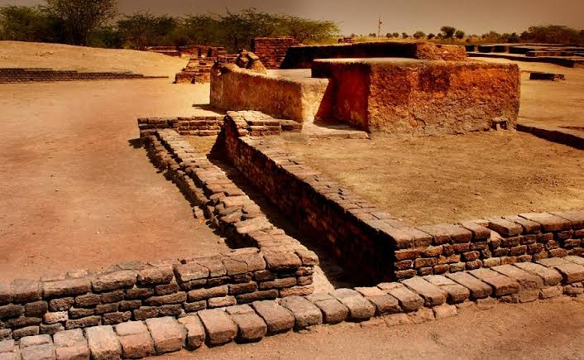

**Fig.1 Drainage system in Indus Valley Civilization.**

**1.1 PROBLEM IN CLEANING THE DRAINAGE:**

Yet,the proper disposal of sewage from drainage is still a challenging task.The disposals are unfortunately sometimes there may be loss of human life while cleaning the clogging in the drainages.This project is about replacing the manual work in drainage cleaning by automated system with the help of sensors.

**1.2 MANUAL SCAVENGING:**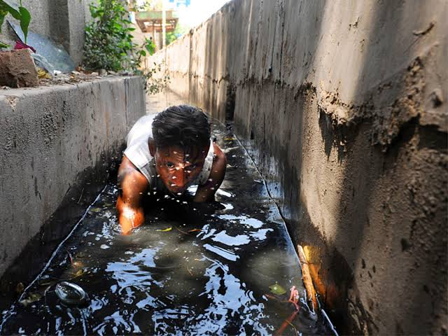

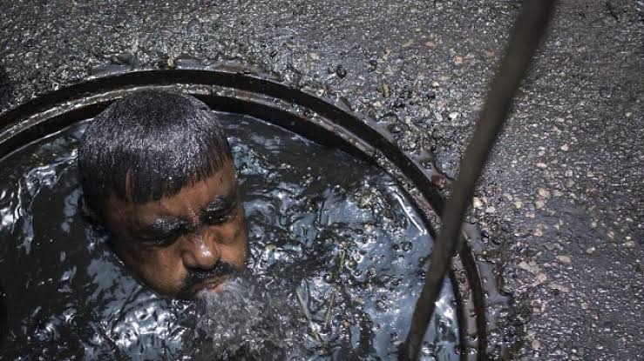

**Fig 2 (a) Fig 2(b)**

In india,the term Manual Scavenging is used to clean and remove the untreated human excreta manually.Manual scavenging refers to the practice of manually cleaning,carrying,disposing or handling in any manner the dry latrines and sewers.It often involves using the most basic of tools such as buckets,brooms,andbaskets.Since 1993,Key legislations have been enacted prohibiting employment of people as manual scavengers.

**1.2.1 Health problems**

Health hazards include exposure to harmful gases,cardiovasculardegeneration,musculoskeletaldisorders,infections,skin problemsand respiratory system problems.

One person dies in every five days,on an average ,while cleaning sewers,septiv tanks and manholes across the country.

**1.3 DRAINAGE CLEANING TECHNOLOGY AVAILABLE :**

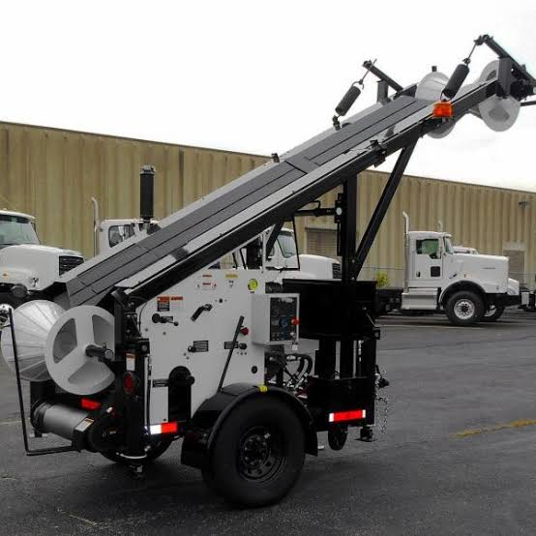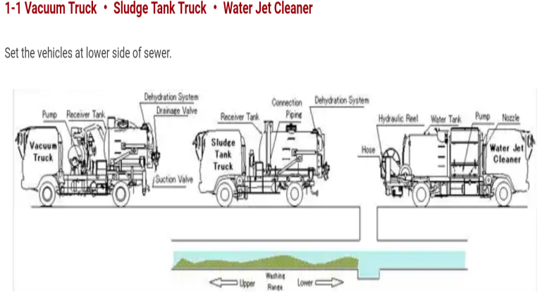  
**Fig.3 Bucket sewer machine in America Fig.4 Sewer Cleaning Machine in Japan.**

Bucket sewer machines (fig.3),In America, they are used bucket sewer technology.This method which is used to clean the drainages by loader through pipe,with the bucket scooping up material as its dragged along in the pipe.

Sewer cleaning machines (fig.4),In Japan They clean all accumulation (sand,mud,sludge.. etc) in sewer with vacuum Trucks, Water Jet Cleaners and Sludge Tank Truck**.**

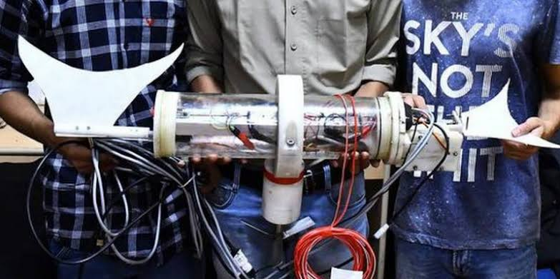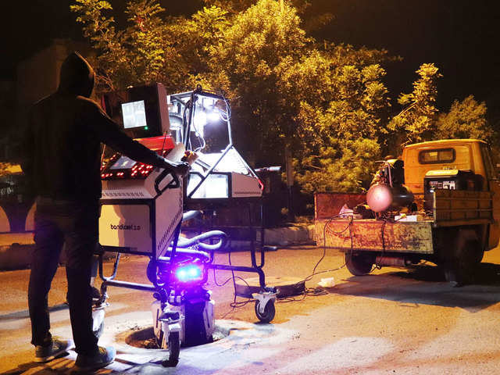

**Fig.5 Sepoy Robot Fig.6 Bandicoot Robot**

IIT-Madras has invented an electronically powered remote-control robot.which can be sent down in the septic lines for the purpose of cleaning. The unique machine is named as SEPOY Septic Tank Robot(Fig.5).

A group of engineers from kerala may have found a way to end the “dehumanizing –practice”. They have designed a spider –shaped robot that cleans manholes and sewers with precision called BANDICOOT(Fig.6), it has already successfully completed a trail run in Thiruvanathapuram. This technologies are only for closed drainage system.

ourindia arevillages based country, most of villages have open drainage systems. Closed drainage systems are constructed only in corporation cities and metro cities.

**2 OBJECTIVES:**

To design and fabricate the low cost open drainage cleaning system for open narrow drainage.

**3 METHODOLOGY:**

**Smart Open Drainage Cleaning System**

**Problem Identification**

See chapter1.1

Calculating dimensions of chain, sprocket, shaft, sheet metal, waste collector

**Concept design**

1. Design of chain drive (sprocket and chain)

2. Design of shaft.

3.Design of bearings.

**Design**

1. Based upon design purchasing the Chain, Sprocket, Shaft, Bearings,12v DC motor, 12 v battery, two water flow sensor, IOT module.

**Material Selection**

**Fabrication**

**Execution**

**3.1 CONCEPT MODEL:**

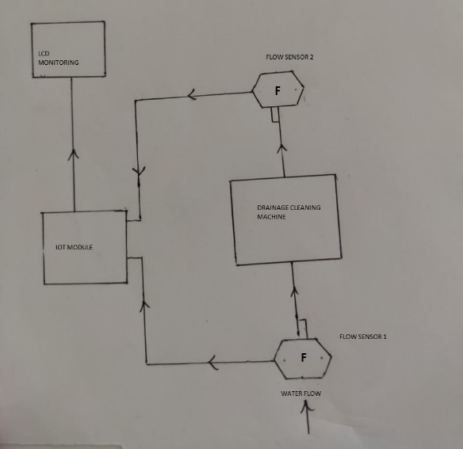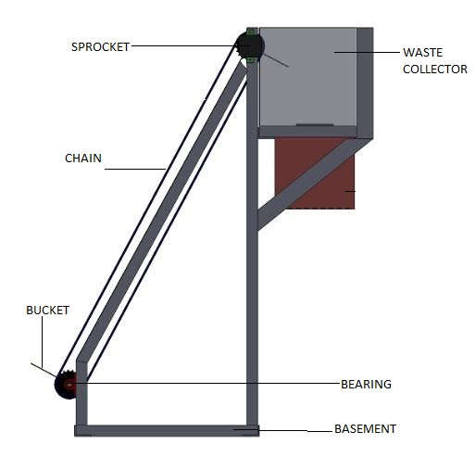

The drainage cleaning machine helps us to clean small or big sewage through its mechanical design and working. This machine consists of parts such as motor, battery, shaft, lifter, collecting box .

This device should be collect the waste like bottles, plastics which are flowing in drain are lifted by teeth of lifter which is connected to conveyor when drainage would be clogging. This conveyor is attached to shafts driven by motor. When motor runs the conveyor starts to circulate making teeth to lift up.The waste material are lifted by teeth and stored in wastecollecter.

**3.1.3Smart technology:**

To detecting blockage and monitoring water level condition with the help of water flow level sensor. Blockage is the major cause of the pollution and flooding in the metro cities. So we have designed the drainage blockage detection system to avoid such problems.

Use of flow sensors to detect the variation in the flow . Collect the data base, Get the prior alerts of blockages and locate them using IOT. Flow sensors at different locations will collect information of sewage flow through that node and send it to the central system which will generate alerts handful of time before complete blockage.

**4 WORKPLAN:**

|  |  |
| --- | --- |
| **CONTENT** | **DATE**  **ON (or) BEFORE** |
| Problem identification | 23 July, 2019 |
| Collecting design parameters | 18 Aug, 2019 |
| Designing of model | 22 Oct, 2019 |
| Material selection | 28 Dec, 2019 |
| Fabrication and Execution | 5 Mar, 2020 |

**5 BUDGET:**

|  |  |  |  |
| --- | --- | --- | --- |
| S.NO. | DESCRIPTION | QUANTITY | AMOUNT |
| 1 | Chain sprocket | 2 pair | 500 |
| 2 | 12V DC motor | 1 | 700 |
| 3 | 12V 7.2Ah Battery | 1 | 1100 |
| 4 | Aluminium frame | 3x3x4 feet | 2000 |
| 5 | Sensors | 2 | 2000 |

**REFERENCES:**

BANDICOOT Technology, Section society ,THE HINDU newspaper published on 01 september 2018.

SEPOY Robot Technology, Section cities, THE HINDU newspaper published on 27 march 2019.

Mr. S. Satpute, “Automatic Sewage Cleaning System” International Journal of Advance Engineering and Research Development, vol 5, april 2018.

A.Nagadeepan, “Automatic Drainage Cleaning System” International journal of Engineering, Science and Mathematics. Vol 7,april 2018.

“Automatic drain and gutter cleaning system” International conference on recent innovations in science and engineering. April 2018.

**6. Has a similar project been carriedout in your college / elsewhere. If** : No

**So furnish details of the previousProject and highlight the improvements**

**Suggested in the presentOne**

**CERTIFICATE**

This is to certify that **G.Sathiyamoorthy, G.Vinoth, P.Chandru, J.Vivekanandhan**are a bonafide final year student of U.G. Engineering course of our college and it is also certified that two copies of utilization certificate and final report along with seminar paper will be sent to the Council after completion of the project by the end of April 2016.

Signature of the Guide Signature of the HOD Signature of the Principal/

Head of the Institution